**SELECTING THE TIME OF CONCENTRATION CONSIDERING GROUNDWATER DEPTH AND RUNOFF COEFFICIENT IN THE ARGENTINIAN PAMPA REGION**

*SELEÇÃO DO TEMPO DE CONCENTRAÇÃO CONSIDERANDO PROFUNDIDADE DAS ÁGUAS SUBTERRÂNEAS E COEFICIENTE DE ESCOAMENTO NA REGIÃO DO PAMPA ARGENTINO*

**Ninoska BRICEÑO1,2, Carlos SCIOLI3, Ilda ENTRAIGAS1,4**

1Instituto de Hidrología de Llanuras "Dr. Eduardo Jorge Usunoff". República de Italia 780 C.C. 47 (B7300) Azul, Buenos Aires, Argentina.

2Consejo Nacional de Investigaciones Científicas y Técnicas (CONICET). Godoy Cruz 2290 (C1425FQB) CABA, Argentina.   
E-mails: [nbriceno@ihlla.org.ar](mailto:nbriceno@ihlla.org.ar)

3Facultad de Ingeniería y Cs. Hídricas (UNL). Ruta Nacional 168, Km 472,4, (3000) Santa Fe, Argentina.   
E-mail: [sciolicarlos@gmail.com](mailto:sciolicarlos@gmail.com)

4Comisión de Investigaciones Científicas. Calle 526 entre 10 y 11 - (1900) La Plata, Argentina. E-mail: [ilda@ihlla.org.ar](mailto:ilda@ihlla.org.ar)

Introduction

Methods

Study area

Data analysis

Estimation of Tc by analytical methods

Estimation of Tc by a graphical method

Event classification according to the runoff generation process

Equation selection procedure

Results and discussion

Analytical methods application

Graphical method application

Event classification

Equation selection procedure

Conclusion

Acknowledgements

References

**RESUMO -** O tempo de concentração (Tc) é um dos parâmetros mais sensíveis para calcular o escoamento máximo em uma bacia e tem papel fundamental na determinação das vazões de projeto. Neste artigo, a consistência das equações que compõem os métodos analíticos utilizados para estimar Tc é avaliada contrastando os eventos observados a partir da aplicação do método gráfico em uma bacia de planície localizada na região dos Pampas, Argentina. A metodologia utilizada considera a complexidade do processo de geração de escoamento superficial e a dinâmica hídrica da região, levando em consideração a análise da profundidade do lençol freático e do coeficiente de escoamento. Este estudo mostra que as equações disponíveis podem gerar previsões de Tc com erros de até 95% em bacias planas. Os resultados indicaram que as equações de Ventura e Pasini são adequadas para determinar a Tc em condições de déficit hídrico, enquanto as equações de Izzard e Onda Cinemática são adequadas para condições de saturação do sistema.

**Palavras-chave:** Tempo de concentração. Precipitação. Escoamento. Bacia de planície. Água subterrânea.

**ABSTRACT -** The time of concentration (Tc) is one of the most sensitive parameters for calculating the maximum runoff in a basin and plays a key role in the determination of design flows. In this work, the consistency of the equations that make up the analytical methods used to estimate the Tc is evaluated through the contrast of observed events from the application of the graphical method in a plain basin located in the Pampa region, Argentina. The methodology used considers the complexity of the runoff generation process and of the water dynamics of the region taking into account the analysis of the groundwater depth and the runoff coefficient. This study shows that the equations available may generate Tc predictions with errors by up to 95% in plain basins. The results indicated that Ventura’s and Pasini’s equations are suitable to determine Tc under water deficit, while Izzard’s and Kinematic Wave equations are appropriate for saturated conditions of the system.

**Keywords:** Time of concentration. Precipitation. Runoff. Plain basin. Groundwater.

INTRODUCTION

The most common definition of time of concen-tration (Tc) of a watershed regards it as the time required for runoff to travel from the hydraulically most distant point to the outlet of a watershed (Kirpich, 1940) when a spatially uniform rainfall occurs all over the region. Determining the time parameters, particularly Tc, represents a challenge in modern hydrology since a unique and precise concept with a generalized consensus is currently not available (Grimaldi et al., 2012).

The Tc is the most widely used time parameter in Hydrology (McCuen et al., 1984; Wong, 2009) and is a relevant variable in mathematical models because it is considered as a primary parameter for different processes simulation. For example, some rainfall-runoff models such as TR-55 (NRCS, 1986), TR-20 (SCS, 1983), HEC-HMS (USACE, 2000), HYMO (Williams & Hann, 1972) and ARHYMO (Maza et al., 1993) take it into account to predict the peak flow. Its impor-tance is also highlighted when developing hydraulic designs, since Tc is necessary for application of the Rational Method (Chow et al., 1988), which is frequently used in calculations related to urban drainage systems, stormwater management systems, bridge/culvert openings and spillways (Sharifi & Hosseini, 2011). Inaccuracies in Tc estimation contribute to significant errors in peak flow calcu-lation. Whereas overestimations may result in the over-sizing of hydraulic engineering structures increasing the cost of construction (Loukas & Quick, 1996), underestimations result in inadequate designs (Gericke & Smithers, 2014) with possible failure or even collapse of a hydraulic structure.

Regarding Tc estimation, it can be carried out using physical, graphical or analytical methods (Kaufmann de Almeida et al., 2017). Physical methods refer to direct measurements by which travel times from different points in a basin are determined through the use of radioactive and chemical tracers (Calkins & Dunne, 1970; Pilgrim, 1976). Graphical methods are those developed from the temporal distribution of observed precipitation and runoff events, considering one time variable from a hyetograph and one time variable from a hydrograph. With respect to analytical methods, the majority refer to equations developed by stepwise multiple regression analysis using geomorphological and climatological characteristics of a catchment as input parameters. Some of these equations were proposed for basins in which channel flows dominate (Williams, 1922; Kirpich, 1940; Johnstone & Cross, 1949; Haktanir & Sezen, 1990), and others for basins where the overland flow regime predominates, as those based on kinematic wave theory (Henderson & Wooding, 1964; Morgali & Linsley, 1965; Woolhiser & Liggett, 1967; Su & Fang, 2004).

Despite the great diversity of ways to determine Tc, all methods have different limitations. A direct measure given by a physical method provides valuable and accurate information but the physical presence of an expert is generally required on the watershed during floods (Pilgrim, 1976). Regarding the graphical method, the main limitation is obtaining the measured data since not all basins have pluviometric and hydrometric stations. As to the analytical method, it has limited applicability and should be used with considerable caution, since each equation has been developed and tested using data from specific watersheds and geographic regions.

With regard to the analytical method in particular, it should be noted that equations are simple and extremely popular because of their limited number of input parameters, but they are often applied without the necessary caution (Sharifi & Hosseini, 2011). Therefore, comparative reviews of these equations have been carried out in order to assess Tc estimation in different regions of the world. In the United States, for example, data from 92 watersheds were considered in order to evaluate different proposals, obtaining acceptable estimates with Kirpich’s and Haktanir & Sezen’s equations (Fang et al., 2005). Particularly in South America, some studies have been carried out in both Uruguay and Brazil. Whereas in Uruguay Izzard equations were proposed as the most appropriate for their application in micro-basins (Bentancor et al., 2014) in Brazil the comparative research between 23 equations yielded standard errors of 20% and 33% for rural and urban watersheds, respectively (Silveira, 2005).

In Argentina, there are no agreed guidelines on the different decision-making and management levels for the elaboration of design hydrographs. Hence, this may promote the choice of those equations which are most frequently used without making a meticulous analysis of their relevance for each system. Moreover, there are no records of applications that particularly contemplate the intrinsic characteristics of plain basins. In these systems, vertical hydrological processes (evapo-ration and infiltration) predominate over horizontal ones (runoff), establishing a strong relationship between the magnitude of the runoff response with the previous humidity state of the system (Sallies, 1999) and the groundwater depth. This last reference is due to the fact that when groundwater reaches levels close to the surface, infiltration is considerably reduced, producing surface surpluses (even with moderate rainfall) that influence Tc.

Taking all these considerations into account, this study focused on the comparison of the Tc values estimated using different equations with those obtained by applying the graphical method (through the analysis of hydrographs and hyetographs). The aim was to identify the most appropriate equations for basins with plain characteristics considering that groundwater depth plays a key role in determining the hydrological state of these systems.

**METHODS**

**Study Area**

The Pampa region constitutes the most important grassland ecosystem in Argentina. The upper Del Azul stream basin covers 1043 km2 in the central zone of this region (Figure 1), with altitudes varying between 143 and 297 m a.s.l. and a mean slope of 2.6%. According to data recorded in the Azul Aero Meteorological Office of the National Meteorological Service, the mean annual precipitation is 962 mm (1989–2018) and the mean annual temperature is 14.4°C. In agreement with the climate classification of Thornthwaite & Mather (1955), the climate of the region is subhumid–humid, mesothermal, with little or no water deficit.

The main water course is Del Azul stream and its main tributaries are Videla and Santa Catalina streams, delineating an integrated drainage network with a dendritic design and relatively coarse texture. Deflationary depressions scattered in the area are permanent or temporary shallow water bodies (dia-meter from 2 to 300 m and between 0.3 and 1.5 m depth) that are added to the drainage network during periods of excess water (Entraigas et al., 2013).

In general, the catchment presents a hydrolo-gical behavior in which the characteristic processes of a plain environment predominate. However, at the headwaters of the drainage network there is a hill environment with slopes that barely exceed 5%, which despite being low values they are significant in relation to the surrounding ones. The entire drainage network, that is, both lotic and lentic bodies, behaves as an effluent element of groundwater, although during events of intense precipitation the surface and underground storage capacity is reached, generating surface runoff (Sala et al., 1987). Phreatic levels dynamics, meanwhile, follow the alternation of climatic variations, being close to the surface during wet periods and at depths of up to 5 m throughout dry periods (Zeme & Varni, 2015).

Soils are well drained and relatively deep so land use is linked to their quality, with extensive agricultural activity being developed mainly with crops dominated by a single implanted species (soybean, corn, barley, wheat, among others), and breeding beef cattle on continuously grazed and set stocking grasslands.

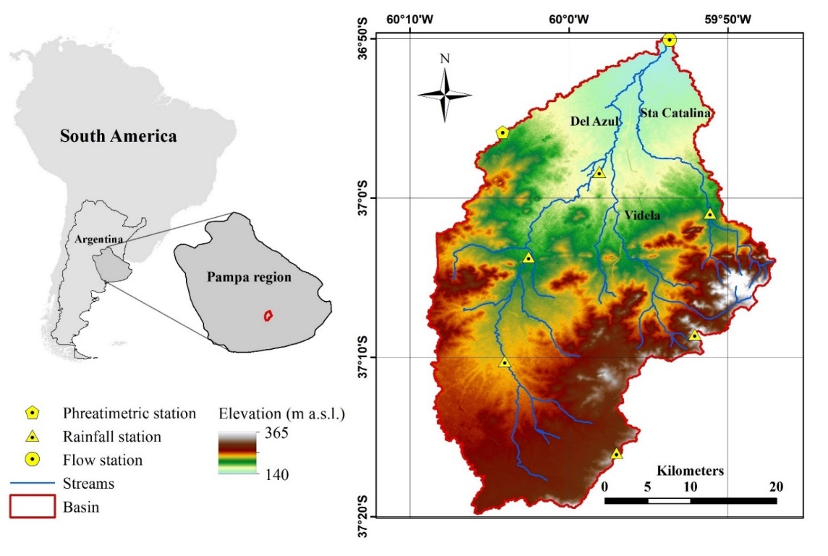

**Figure 1 -** Geographic location of the study area.

The study area is instrumented with seven automatic stations belonging to the Institute for Large Plains Hydrology network (IHLLA, after its Spanish acronym), six are pluviometric and one is hydrometric. The temporal resolution of the analyzed data was unified at 1 hour for all stations throughout the 2006-2017 period. In addition, a phreatimetric station with continuous recording is located in the area; it has been active since 2007 and has been used in previous studies to characterize the groundwater dynamics of the region (Comas & Varni, 2009).

**Data Analysis**

***Estimation of Tc by analytical methods***

There are many equations available in the hydrological literature to estimate Tc based on analyzing geomorphological, hydrological and meteorological data gathered from a particular geographic region. Table 1 shows a compilation of 29 equations.

**Table 1 -** Analytical methods applied to estimate the time of concentration and its main characteristics. ADOT: Arizona Department of Transportation; CCP: California Culvert Practice; DNOS: Departamento Nacional de Obras de Saneamento; FAA: Federal Aviation Administration; SCS: Soil Conservation Service. * Derived from the relationship $T_{R}$ = 0.6 $Tc$ (Mockus, 1957); ** Derived from the relationship $Tc$ =1.417 $T_{R}$ (McCuen et al., 1984).

|  |  |  |
| --- | --- | --- |
| **Method and reference** | **Equation** | **Comments** |
| ADOT (1993) |  | Agricultural basins |
| Bransby Williams  (Wanielista et al., 1977) |  | Rural basins |
| Carter (1961) |  | 1 urban basin in the USA. $A$ <20.72 km2;<0.005 |
| Chow  (Chow et al., 1988) |  | 20 rural basins in the USA. $A$ 0.01 - 18.5 km2; 0.005 - 0.09.**\*** |
| CCP (CHPW, 1955) |  | Mountain basins in California. $A$ < 40.47 km2 |
| Corps of Engineers  (MOPU, 1987) |  | 25 rural basins in the USA. $A$ <12.000 km2 |
| DNOS (Silveira, 2005) |  | 6 rural basins in the USA.<0.45km2; 0.03-0.1 |
| Dooge (1973) |  | 10 rural basins in Ireland. $A$ 45 -948 km2 |
| (Espey et al., 1966) |  | 11 rural basins in the USA |
| FAA (1970) |  | Urban basins |
| Giandotti (1934) |  | 12 basins in Italy. $A$ 170 - 70,000 km 2 |
| Haktanir & Senzen (1990) |  | 10 basins in Turkey. $A$ 11 - 9,867 km 2**\*** |
| Izzard (1946) |  | Developed for surface flow over pavement and dense turf |
| Johnstone & Cross (1949) |  | Rural basins in the USA. $A$ 64.8-4,206.1km2 |
| Kerby (1959) |  | Basins in the USA.<0.04 km 2;<0.01 |
| Kinematic Wave  (Morgali & Linsley, 1965) |  | From kinematic wave analysis of surface runoff |
| Kirpich (1940) |  | Rural basins in Tennessee. $A$ 0.004 - 0.453 km2; 0.03 - 0.1 |
| McCuen et al. (1984) |  | 48 urban basins in the USA. $A$ 0.4 - 16 km2; 0.0007 - 0.03 |
| Papadakis & Kazan (1987) |  | 84 rural basins in the USA. < 5 km2 |
| Pasini (1910) |  | Rural basins in Italy. $A$ 40 - 70,000 km2 |
| Picking (Silveira, 2005) |  | Rural basins |
| Pilgrim & McDermott (1981) |  | 96 basins in Australia. $A$ < 250 km² |
| Ribeiro (1961) |  | Rural basins in India and the USA. $A$ < 19,000 km2; 0.03-0.1 |
| SCS Lag (SCS, 1972) |  | Basins with $A$ < 8 km². **\*** |
| Simas & Hawkins (2002) |  | 168 basins in the USA. $A$ 0.001 - 14 km2. **\*\*** |
| Témez (1978) |  | Natural basins in Spain. $A$ < 3,000 km2 |
| Ventura (1905) |  | Rural basins in Italy |
| Williams **(1922)** |  | Basins in India. $A$ < 129.5 km2 |
| Yen & Chow (1983) |  | Based on the Kinematic Wave Theory |

Note: $Tc$ (h): time of concentration; (km2): watershed area; $L$ (km): length of main channel or hydraulic length of the watershed; $Lc$ (m): length measured from the concentration point along L to a point on L that is perpendicular to the watershed centroid; (mm-1): slope of main channel or slope of the longest hydraulic length; (mm-1): average slope of watershed; $p$ (adm): relationship between area covered with vegetation and total watershed area; $∆H$ (m): height difference between edges of main water line; $H_{m}$ (m): average altitude of watershed (mean elevation starting from the outlet); $CN$ (adm): curve number parameter of the SCS method; $S_{SCS}$ (mm): maximum capacity of retention; $C$ (adm): runoff coefficient; $n$ (adm): Manning’s roughness coefficient; $k$ (adm): coefficient of the type of surface; $D$ (km): equivalent diameter of the watershed; (mmh-1): rainfall intensity.

In some cases, their original format was changed in order to unify the measurements to the international system of units. It is important to highlight that on some occasions the selected equations were applied outside the recommended valid ranges, since each of them is based on specific physical characteristics that differ from those of the upper Del Azul stream basin. It should also be noted that an exhaustive analysis was carried out both of articles written by the equations’ authors, and of review works that propose comparisons between some of them in different regions of the world, such as South America (Silveira, 2005; Mata-Lima et al., 2007; Kaufmann de Almeida et al., 2014), Africa (Gericke & Smithers, 2014) and Europe (Ravazzani et al., 2019).

The parameters of the study area used in different equations are presented in Table 2. Some of them (such us area, slope, length of the main channel, etc.) were obtained from GIS routines application, while others were derived from the analysis of standardized classifications. Thus, Manning Roughness Coefficient value was determined from Chow's proposal (1964), while Surface Type Coefficient was established according to Mello (1973).

***Estimation of Tc by a graphical method***

Time variables can be estimated from the spatial and temporal distributions of both rainfall and runoff. Rainfall hyetographs analyses are based on the separation of initial abstraction, losses and effective rainfall; and the hydrograph analyses are based on the separation of the total runoff hydrographs into direct runoff and base-flow (Gericke & Smithers, 2014). A total of 21 events were selected for our study, taking into account that the temporal distribution was uniform (with single peak hydrograph) and that the spatial distribution was homogeneous (variation coefficients of the accumulated rainfall less than 30% among the stations for each occasion).

Average precipitation was calculated using the Thiessen method (Thiessen, 1911). This consists of assigning a weight factor to total rainfall values at each pluviometer, proportional to the influence area of each one. Then, the method developed by the NRCS (Mockus, 1972) was applied to separate the portion of precipitation that generated direct runoff (that is, effective precipitation).

**Table 2** - Characteristics of the upper Del Azul stream basin considered in the equations.

|  |  |  |
| --- | --- | --- |
| **Basin parameters** | **Value** | **Units** |
| **Area** | 1043.7 | km2 |
| **Average watershed altitude** | 82.5 | m |
| **Runoff coefficient** | 0.16 | - |
| **Manning’s roughness coefficient** | 0.04 | - |
| **Type of surface coefficient** | 2 | - |
| **Lower elevation of the main channel** | 142.9 | m |
| **Higher elevation of the hydraulic length** | 296.7 | m |
| **Higher elevation of the main channel** | 217.7 | m |
| **Equivalent diameter of the watershed** | 78.53 | km |
| **Elevation difference of the hydraulic length** | 153.8 | m |
| **Elevation difference of the main channel** | 74.8 | m |
| **Rainfall intensity** | 2.3 | mmh-1 |
| **Main channel length** | 61.67 | km |
| **Hydraulic length of the watershed (the longest flow path)** | 84.76 | km |
| **Length measured from the concentration point along L to a point on L that is perpendicular to the watershed centroid** | 42.2 | km |
| **Curve number** | 60 | - |
| **Slope of the longest hydraulic length** | 0.18 | % |
| **Main channel slope** | 0.12 | % |
| **Average watershed slope** | 2.62 | % |
| **Relationship between area covered with vegetation and total watershed area** | 0.62 | - |

Moreover, a graphical approach was used to separate the hydrograph components. The Method of Graphical Base-flow Separation (Chow et al., 1988) was applied considering a straight line from the beginning of hydrograph rise to the inflection point of the recession curve, where it begins to become asymptotic and it is assumed that the contribution of surface runoff is finished. Then the Runoff Coefficient (CR) for each event was determined, corresponding to the ratio between the amount of direct runoff and the precipitation sheet.

A description of the selected events was made considering the storm duration, the total precipitation, the precipitation of the 5 days prior to the event, the maximum intensity and the water table.

There are several graphical methods for time parameters estimation taking into account precipitation and runoff observations (McCuen, 2009). In our study we adopt the definition that refers to Tc as the time from the end of rainfall excess to the inflection point on the total storm hydrograph (Figure 2).

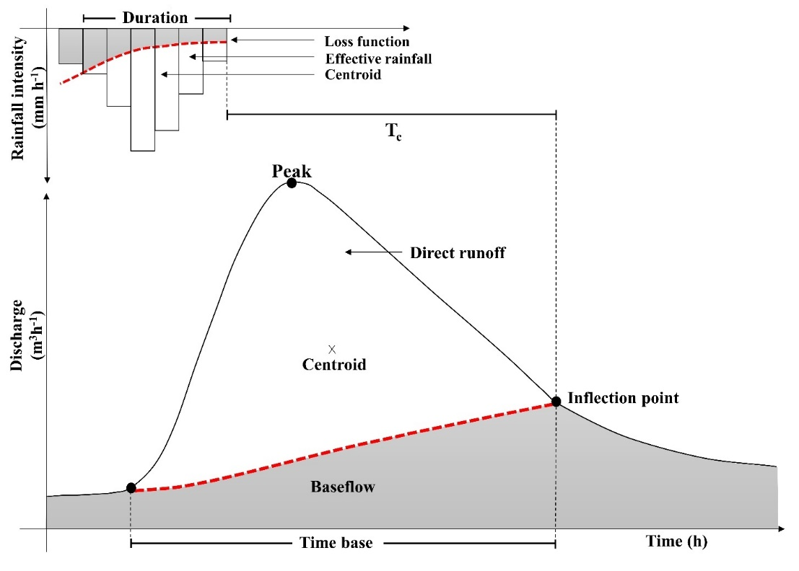

**Figure 2 -** Schematic diagram illustrative of the Tc definition used in this work.

**Event classification according to the runoff generation process**

Surface runoff is mainly generated by two mechanisms, infiltration excess runoff and saturation excess runoff. The first, also called Hortonian flow, occurs when the rainfall intensity exceeds the soil infiltration capacity (Horton, 1933), while the latter, also called Dunnean Flow, refers to those situations in which rain falls on areas where the soil profile is saturated by the discharge of shallow groundwater (Dunne & Black, 1970). Thus, in order to classify the events according to their runoff generation process, a relationship between WT, CR and Tc was established.

**Equation selection procedure**

Finally, relative differences between Tc derived from the application of empirical equations (${Tc}_{E}$) and the mean Tc value obtained through the graphical method (${Tc}_{G}$) were calculated, allowing comparisons between them and thus selecting the most appropriate equations for basins with plain characteristics. Subsequently, those differences were assessed to detect bias in predictions (over or underestimation) by calculating the mean error ($ME$).



Where:

${Tc}_{E}$ = Tc derived from the application of empirical equations.

${Tc}_{G}$ = Tcobtained through the graphical method.

$N$ = Total number of events.

**RESULTS AND DISCUSSION**

**Analytical Methods Application**

We selected 29 equations in order to compare their estimates and to quantify the accuracy in reproducing Tc retrieved from observations in our study area. It is important to point out that the equation proposed by Morgali & Linsley (1965) was considered as the representative of those derived from the uniform flow theory and basic wave mechanics based on the kinematic wave. All of them are extremely similar, e.g., Henderson & Wooding's (1964) and Woolhiser & Liggett's (1967) equations.

The Tc values obtained by applying the aforementioned equations are shown in Figure 3. The variability in equations performance ranged up to 84%. Among the values estimated by the equations, the highest value was 113 h, derived using Pasini’s equation, and the lowest values were 5, 9 and 11 h, using Kerby, Carter and Pilgrim & McDermott’s equations, respectively.

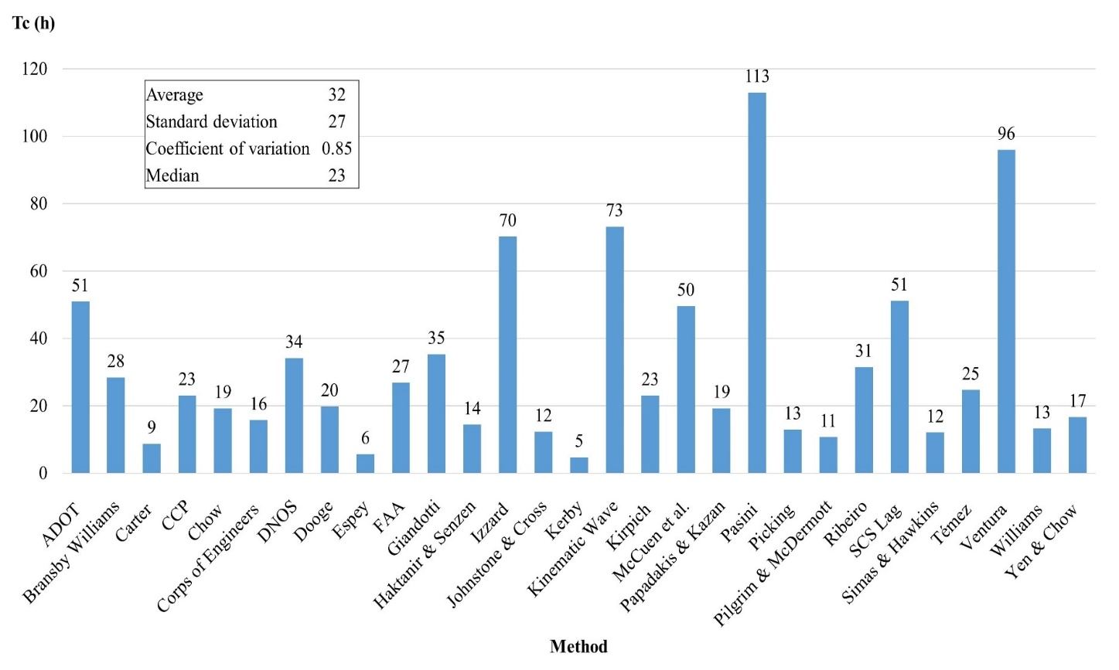

**Figure 3 -** Tc obtained by applying analytical methods.

The mean Tc value obtained was 32 h. It was observed that 69% of the different equations analyzed yielded results lower than that and 31% above that value. The high versatility of the results obtained highlighted the need to carry out a careful assessment on the accuracy of the Tc equations based on data from a particular area, prior to the choice and application of one of them.

A relevant aspect found in the available equations was the inconsistency of parameters since on many occasions the technique used for determining the parameters is not properly specified. For example, for a given equation, in some research the length of the channel refers to the hydraulic length of the basin, that is, the longest flow path, while in others it refers to the length of the main channel. This difference represents up to 10% of its value for the system under study, which indicates that for larger basins the error generated could increase even more.

Another parameter whose distinction in the literature is not frequently explained in detail is the slope, since sometimes it could refer to the overland slope, basin relief, or channel slope. Silveira (2005) is one of the few authors who makes a clear distinction for these parameters for some of the equations used in this study. For the rest of the formulas, the most frequently applied determination in the consulted bibliography was used as a reference.

Furthermore, another source of inconsistency is due to the variety of input parameter units. For example, the slope parameter specified in equations cited herein was required at times in units equivalent to mm-1, mkm-1, and percent, not always properly explicit. All this uncertainty makes the user incur in generating significant errors in the Tc calculation (Sheridan, 1994).

**Graphical Method Application**

Before applying the graphic method to calculate Tc, it was necessary to analyze the characteristics of the 21 selected events (Table 3), particularly regarding the shape of the hydrographs and hyetographs recorded.

The mean Tc value obtained for the selected events (Table 4) was 85 hours. The longest Tc value was 128 hours (occurred on May 3, 2015) and the shortest one was 60 hours (August 17, 2012).

**Table 3 -** General characteristics of the selected events (the absence of the first value corresponding to WT is due to the fact that the phreatimetric station began to operate in 2007).

|  |  |  |  |  |  |  |  |  |  |  |
| --- | --- | --- | --- | --- | --- | --- | --- | --- | --- | --- |
| **Event** | **Date** | **D (h)** | **P (mm)** | **imax (mmh**-1**)** | **Q (mm)** | **q (mm)** | **qd (mm)** | **qpk(m3s**-1**)** | **CR (-)** | **WT(m)** |
| **1** | 10/15/06 | 20 | 70.1 | 18.6 | 6.0 | 1.26 | 4.76 | 38.27 | 0.07 | - |
| **2** | 03/09/07 | 13 | 108.9 | 40.7 | 10.8 | 1.68 | 9.16 | 62.77 | 0.08 | 1.78 |
| **3** | 09/15/07 | 40 | 66.7 | 10.8 | 11.8 | 3.48 | 8.30 | 81.20 | 0.12 | 2.02 |
| **4** | 10/04/07 | 29 | 42.7 | 7.8 | 5.9 | 2.33 | 3.52 | 27.58 | 0.08 | 1.51 |
| **5** | 05/18/12 | 39 | 141.8 | 16.4 | 43.0 | 9.17 | 33.84 | 286.66 | 0.24 | 0.77 |
| **6** | 08/08/12 | 26 | 51.8 | 6.4 | 6.0 | 2.30 | 3.70 | 27.40 | 0.07 | 1.54 |
| **7** | 08/17/12 | 44 | 100.4 | 10.8 | 48.0 | 9.73 | 38.17 | 269.16 | 0.38 | 0.74 |
| **8** | 08/25/12 | 28 | 66.4 | 8.6 | 41.5 | 11.35 | 30.13 | 265.12 | 0.45 | 0.27 |
| **9** | 09/05/12 | 25 | 26.5 | 5.0 | 10.4 | 5.81 | 4.60 | 47.17 | 0.17 | 0.67 |
| **10** | 10/07/12 | 9 | 29.3 | 5.9 | 4.4 | 2.22 | 2.17 | 22.44 | 0.07 | 1.10 |
| **11** | 10/18/12 | 22 | 40.0 | 6.2 | 5.9 | 2.55 | 3.38 | 27.40 | 0.08 | 0.87 |
| **12** | 12/21/12 | 6 | 47.1 | 24.7 | 5.1 | 2.19 | 2.90 | 25.29 | 0.06 | 0.68 |
| **13** | 05/25/14 | 36 | 38.8 | 4.9 | 7.1 | 2.96 | 4.12 | 24.30 | 0.11 | 1.91 |
| **14** | 06/13/14 | 35 | 64.9 | 12.8 | 20.8 | 7.58 | 13.22 | 164.16 | 0.20 | 1.50 |
| **15** | 07/07/14 | 42 | 54.0 | 4.1 | 18.5 | 6.86 | 11.64 | 94.86 | 0.22 | 1.26 |
| **16** | 08/23/14 | 45 | 75.4 | 10.3 | 23.9 | 11.22 | 12.71 | 195.32 | 0.17 | 1.22 |
| **17** | 09/06/14 | 22 | 40.1 | 12.1 | 26.3 | 8.24 | 18.01 | 188.87 | 0.45 | 0.84 |
| **18** | 05/03/15 | 32 | 82.2 | 4.6 | 8.6 | 3.05 | 5.55 | 27.58 | 0.07 | 2.26 |
| **19** | 10/30/15 | 13 | 50.8 | 20.2 | 4.2 | 1.63 | 2.58 | 23.33 | 0.05 | 1.67 |
| **20** | 05/20/17 | 23 | 71.1 | 10.4 | 10.7 | 2.89 | 7.83 | 47.17 | 0.11 | 3.00 |
| **21** | 06/28/17 | 31 | 48.4 | 8.5 | 8.7 | 2.93 | 5.76 | 36.86 | 0.12 | 3.00 |

Note: **D**: Rainfall duration; **P**: total precipitation; **imax**: maximum rainfall intensity; **Q**: total flow; **q**: base-flow; **qd**: direct flow; **qpk**: peak flow; **CR**: runoff coefficient; **WT**: water table.

**Table 4 -** Tc obtained by applying the graphic method.

|  |  |  |
| --- | --- | --- |
| **Event** | **Date** | **Tc (h)** |
| **1** | 10/15/06 | 97 |
| **2** | 03/09/07 | 99 |
| **3** | 09/15/07 | 74 |
| **4** | 10/04/07 | 93 |
| **5** | 05/18/12 | 65 |
| **6** | 08/08/12 | 73 |
| **7** | 08/17/12 | 60 |
| **8** | 08/25/12 | 67 |
| **9** | 09/05/12 | 89 |
| **10** | 10/07/12 | 82 |
| **11** | 10/18/12 | 88 |
| **12** | 12/21/12 | 94 |
| **13** | 05/25/14 | 107 |
| **14** | 06/13/14 | 80 |
| **15** | 07/07/14 | 87 |
| **16** | 08/23/14 | 61 |
| **17** | 09/06/14 | 63 |
| **18** | 05/03/15 | 128 |
| **19** | 10/30/15 | 86 |
| **20** | 05/20/17 | 99 |
| **21** | 06/28/17 | 91 |
| **Average** | | 85 |
| **Standard deviation** | | 17 |
| **Coefficient of variation** | | 0.2 |
| **Median** | | 87 |

The wide difference between these values would reflect the strong interaction between surface and groundwater that characterizes the plain areas. Thus, during long Tc events the water table would be at a greater depth, so vertical processes (evapotranspiration and infiltration) predominate, while during short Tc events the water table would be closer to the surface, with an increased prominence of horizontal movements (runoff).

Under deep water table conditions, runoff generation in plain areas is often originated by the Hortonian mechanism, that is, when the rainfall intensity exceeds the soil infiltration rate. The moisture content at the surface increases as a function of time and, at some point in time, the infiltration rate drops below the rainfall rate and overland flow is produced.

This process is characterized by low runoff coefficients, since a portion of the precipitation is retained by the soil and, furthermore, the overland flow moves slowly because it must fill the depressed areas as it runs through the landscape.

On the other hand, under shallow water table conditions, the surface runoff production is accelerated because the depressed areas of the landscape are already filled with groundwater, quickly reaching a hydraulic slope that enables flow acceleration. The occurrence of precipitation over a system where the soil profile is saturated and the depressions filled because of the rise of the water table, generates a surface flow through the Dunnean mechanism in which the net rainfall is greater and, consequently, the runoff coefficient is high.

**Event Classification**

With the aim of identifying the runoff generation mechanisms in the basin, both the CR of each event and the associated WT were related with the Tc determined through the measured hydrographs (Figure 4). For a better visualization, the CR values were classified into those greater or less than 0.15 (considered as high or low values, respectively); while the WT values were classified depending on whether they were at a depth greater or less than 1.5 m (considered deep or shallow, respectively). In this way, three scenarios were defined:

I - System with high values of CR, shallow WT and short Tc, therefore the Dunnean mechanism of runoff generation prevails.

II - System with low values of CR, deep WT and long Tc, therefore the Hortonian mechanism of runoff generation predominates.

III - Transition conditions, in which case only some of the circumstances established in scenario I or II are met.

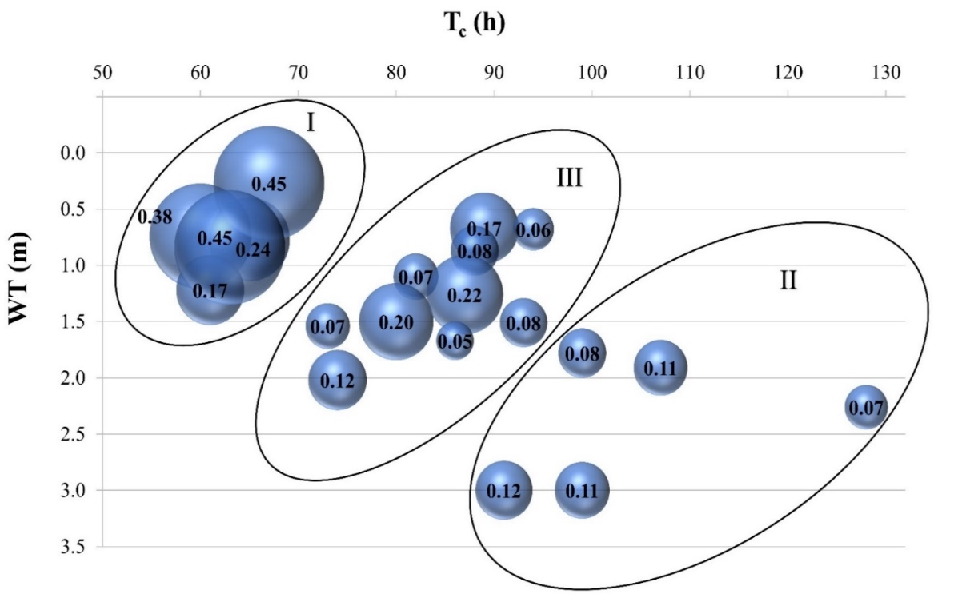

**Figure 4 -** Events classification from the relation between Tc, WT and CR (bubble size indicates CR values).

In order to simplify the general characterization of the hydrological basin response in just 2 opposing scenarios, the mean Tc value was selected as the system response threshold. In this way, Tc values longer than 85 hours were considered as long Tc events corresponding to a water deficit state of the basin represented by the Hortonian runoff generation mechanism (scenario II), while Tcshorter than this value were classified as short Tc events corresponding to a saturated state of the basin determined by the Dunnean runoff generation mechanism (scenario I).

The mean value for each data set was 97 and 69 hours, respectively.

**Equation Selection Procedure**

The relative differences between Tc values estimated by applying the evaluated equations and the mean value obtained by the graphical method were calculated for the three subsets: all the events, the events with long Tc and those with short Tc (Table 5).

Considering all the events, the relative differences between both methods ranged from 13% (Ventura) to 95% (Kerby). However, if only equations with errors lower than 20% are taken into account, so Ventura (0.6%) and Pasini (17.1%) are best positioned for long Tc subset, and Izzard (1.1%) and Kinematic Wave (5.4%) for the short Tc subset.

The decision to group events into short and long Tcallowed identifying the analytical methods that best represent the basin performance in each scenario. In this way, it was observed that the most appropriate equations for long Tc events (occasions when the soil profile is dry) are based on the watershed geometry, while in the case of short Tc events (occasions when the soil profile is saturated) the equations are based both on surface properties such as soil type and vegetation cover, and storm characteristics such as rainfall intensity (Table 6).

**Table 5 -** Differences between Tc values obtained by the graphical method and by analytical methods (the equations are ordered in increasing order according to the error values when considering all the Tc.

|  |  |  |  |
| --- | --- | --- | --- |
| **Equation** | **All Tc**  **Error (%)** | **Long Tc Error (%)** | **Short Tc**  **Error (%)** |
|
| **Ventura** | 13.0 | **0.6** | 38.1 |
| **Kinematic Wave** | 13.8 | 24.2 | **5.4** |
| **Izzard** | 17.3 | 27.3 | **1.1** |
| **Pasini** | 33.1 | **17.1** | 62.7 |
| **SCS Lag** | 39.8 | 47.0 | 26.4 |
| **ADOT** | 40.1 | 47.3 | 26.7 |
| **McCuen et al.** | 41.6 | 48.6 | 28.6 |
| **Giandotti** | 58.4 | 63.4 | 49.2 |
| **DNOS** | 59.8 | 64.7 | 50.9 |
| **Ribeiro** | 62.9 | 67.4 | 54.7 |
| **Bransby Williams** | 66.6 | 70.6 | 59.1 |
| **FAA** | 68.4 | 72.2 | 61.4 |
| **Témez** | 71.0 | 74.5 | 64.5 |
| **CCP** | 72.8 | 76.1 | 66.8 |
| **Kirpich** | 72.9 | 76.2 | 66.9 |
| **Dooge** | 76.7 | 79.5 | 71.6 |
| **Papadakis & Kazan** | 77.3 | 80.0 | 72.3 |
| **Chow** | 77.4 | 80.1 | 72.3 |
| **Yen & Chow** | 80.5 | 82.8 | 76.1 |
| **Corps of Engineers** | 81.5 | 83.7 | 77.4 |
| **Haktanir & Senzen** | 83.1 | 85.2 | 79.4 |
| **Williams** | 84.5 | 86.3 | 81.0 |
| **Picking** | 84.8 | 86.6 | 81.4 |
| **Johnstone & Cross** | 85.6 | 87.3 | 82.4 |
| **Simas & Hawkins** | 85.9 | 87.6 | 82.7 |
| **Pilgrim & McDermott** | 87.4 | 89.0 | 84.6 |
| **Carter** | 89.8 | 91.0 | 87.5 |
| **Espey** | 93.4 | 94.2 | 91.9 |
| **Kerby** | 94.5 | 95.1 | 93.2 |

**Table 6 -** Basin characteristics considered in the structure of the equations that best fit for long and short Tc.

|  |  |  |  |  |  |  |  |
| --- | --- | --- | --- | --- | --- | --- | --- |
| **Tc** | **Method** | $$A$$ | $$L$$ | $$S$$ | $$i$$ | $$n$$ | $$∆H$$ |
| **Long** | Ventura | … | … |  |  |  | … |
| Pasini | … | … | … |  |  |  |
| **Short** | Izzard |  | … | … | … | … |  |
| Kinematic Wave |  | … | … | … | … |  |

Note: $A$: watershed area; $L$: length of main channel or hydraulic length of the watershed; $S$: slope of main channel or slope of the longest hydraulic length; $∆H$: height difference between edges of main water line; $n$: Manning’s roughness coefficient; $i$: rainfall intensity.

Ventura’s and Pasini’s equations showed a similar performance in the system under study, being adequate to represent long Tc events. In this sense, based on the mean error (ME), Ventura’s equation slightly underestimates (-0.6) and Pasini’s equation overestimates (16.5) the Tc value. These equations were originally proposed for rural watersheds in Italy, and both are recommended for small and medium basins with not very steep slopes.

On the other hand, Izzard’s and Kinematic Wave equations were originally proposed to estimate the surface runoff (Fang et al., 2005) and were appropriate to describe short Tc events in the basin (they both overestimate the Tc values, 0.7 and 3.7 respectively). It should be noted these equations are related to each other, since Izzard defined the equilibrium time as the time interval necessary for the runoff rate to be equal to the supply rate, and later Morgali and Linsley proposed the Kinematic Wave equation based on that definition.

**CONCLUSION**

Current availability of a hydrometeorological database for the upper Del Azul stream basin, which includes continuous data of precipitation, flow and water table, provided an opportunity to analyze 29 equations for the Tc estimation. It was shown that very different results are obtained from the application of various equations. The graphical method was found to be reliable and also allows the individual analysis of the basin response to distinct events in terms of both duration and intensity of precipitation.

Performance variations were found amongst the equations. Hence, none of them provides adequate precision since they were originally proposed for systems with characteristics other than the upper Del Azul stream basin. This demonstrates the need to carry out a specific evaluation for each study area where these equations are applied. Additionally, the uncertainty involved in the process of Tc estimation deepens by the use of different conceptual definitions in the literature to define the parameters (and their units) involved in each equation. Plain basins have a particular behavior since their response, in addition to being conditioned by the hydrological state of the system and the characteristics of the precipitation event, depends to a great extent on the groundwater dynamics. At the time of assessing the Tc of a flat basin, it was shown that errors derived from equations application were reduced when considering the depth of the WT. Thus, runoff events with a slow response (long Tc) generally occur when the WT is deep, while runoff events with a fast response (short Tc) occur when the WT is shallow and the soil is saturated. So, from the exhaustive analysis of the obtained results and addressing the particularities of the upper Del Azul stream basin, the application of Ventura’s and Pasini’s equations is proposed in plain systems for the determination of long Tc events, and Izzard’s and Kinematic Wave equations for the short Tc events.

This study shows that the equations available may generate Tc predictions with errors by up to 95% in plain basins. Therefore, it is recommended to carry out a critical evaluation when selecting the most suitable equation for its estimation. A careful adjustment of this parameter is deemed necessary to achieve an adequate estimation of the maximum flow involved in the calculation of hydraulic works. This would result, among many other benefits, in optimizing the representativeness of hydrological models. Consequently, factors such as safety, public health, and economy would be positively affected with appropriate investments in water resources management.

**ACKNOWLEDGEMENTS**

We are grateful to Enrique Queupán and Joaquín Rodríguez for field assistance; Eng. Martin Blanco and Dr. Guadalupe Ares for their invaluable contribution in the discussion of preliminary results; and Professor Mariana Oyarzabal for the review comments on the manuscript. This study was funded by the National Agency for Scientific and Technological Promotion, Project BID-PICT 2016-3688; and the National Scientific and Technical Research Council, Project UE Nº 22920200100035CO.

*Ninoska Briceño is a graduate student in the Environment and Health Applied Sciences Doctoral Program (DCAAS) at UNICEN, Argentina.

**REFERENCES**

ADOT (Arizona Department of Transportation). **Highway Drainage Design Manual Hydrology**. Phoenix, AZ: Arizona Department of Transportation, 336 p., 1993.

BENTANCOR, L.; SILVEIRA, L.; GARCÍA PETILLO, M. Incidencia de la intensidad de lluvia en el tiempo de concentración de microcuencas del Uruguay. **Agrociencia Uruguay**, v. 18, n. 2, p. 106-116, 2014.

CALKINS, D. & DUNNE, T. A salt tracing method for measuring channel velocities in small mountain streams. **Journal of Hydrology**, v. 11, n. 4, p. 379-392, 1970.

CARTER, R.W. Magnitude and frequency of floods in suburban areas. U.S. **Geological Survey Professional Pape**r, v. 424-B, p. B9–B11, 1961.

CHOW, V.T. **Hidráulica de canales abiertos**. Santafé de Bogotá, Colombia: McGraw-Hill, 667 p., 1964.

CHOW, V.T.; MAIDMENT, D.R.; MAYS, L.W. **Applied hydrology.** New York: McGraw-Hill, 570 p., 1988.

CHPW (California Highways and Public Works). **California culvert practice: Reprint of a series of technical abstracts [appearing in each issue from Aug. 1942 to Sept.-Oct. 1943]**. Sacramento, CA: Department of Public Works / Division of Highways, 1955.

COMAS, R. & VARNI, M. Análisis de variaciones del nivel freático en una red de piezómetros en la cuenca del arroyo del Azul. In: VI CONGRESO ARGENTINO DE HIDROGEO-LOGÍA, 2009, Santa Rosa, Argentina. **Actas**… Santa Rosa, Argentina: Amerindia Nexo Di Napoli, 2009, p. 269-278.

DOOGE, J.C.I. **Linear theory of hydrologic systems.** Washington, D.C.: Agricultural Research Service / U.S. Departement of Agriculture, 1973.

DUNNE, T. & BLACK, R.D. Partial area contributions to storm runoff in a small New England watershed. **Water Resources Research**, v. 6, n. 5, p. 1296-1311, 1970.

ENTRAIGAS, I.; VERCELLI, N.; MIGUELTORENA, V. **Los paisajes de la cuenca del arroyo del Azul**. Mar del Plata, Argentina: Martín, 123 p., 2013.

ESPEY, W.H.J.; MORGAN, C.W.; MASCH, F.D. **A study of some effects of urbanization on storm runoff from a small watershed**. Austin, TX: Center for Research in Water Resources / University of Texas and the Texas Water Development Board, 1966.

FAA (Federal Aviation Administration). **Advisory circular on airport drainage**. Washington, D.C.: U.S. Department of transportation, 1970.

FANG, X.; CLEVELAND, T.; GARCIA, C.A.; THOMPSON, D.; MALLA, R. **Literature review on timing parameters for hydrographs**. Beaumont, Texas: Department of Civil Engineering / Lamar University, 77 p., 2005.

GERICKE, O.J. & SMITHERS, J.C. Review of methods used to estimate catchment response time for the purpose of peak discharge estimation. **Hydrological Sciences Journal**, v. 59, n. 11, p. 1935-1971, 2014.

GIANDOTTI, M. Previsione delle piene e delle magre dei corsi d’acqua. Rome: Memorie e studi idrografici. **Servizio Idrografico Italiano**, p. 107-117, 1934.

GRIMALDI, S.; PETROSELLI, A.; TAURO, F.; PORFIRI, M. Time of concentration: a paradox in modern hydrology. **Hydrological Sciences Journal**, v. 57, n. 2, p. 217-228, 2012.

HAKTANIR, T. & SEZEN, N. Suitability of two-parameter gamma and three-parameter beta distributions as synthetic unit hydrographs in anatolia. **Hydrological Sciences Journal**, v. 35, n. 2, p. 167-184, 1990.

HENDERSON, F.M. & WOODING, R.A. Overland flow and groundwater flow from a steady rainfall of finite duration. **Journal of Geophisical Research**, v. 69, n. 8, p. 1531-1540, 1964.

HORTON, R.E. The role of infiltration in the hydrology cycle. **Transactions, American Geophysical Union**, p. 446-460, 1933.

IZZARD, C.F. Hydraulics of runoff from developed surfaces. In: PROCEEDINGS OF THE 26TH ANNUAL MEETING THE HIGHWAY RESEARCH BOARD, NATIONAL RESEARCH COUNCIL, 1946, Washington, D.C. **Proceedings**… Washington, D.C.: National Research Council, 1946, p. 129–146.

JOHNSTONE, D. & CROSS, W.P. **Elements of applied hydrology**. New York: Ronald Press Company, 1949.

KAUFMANN DE ALMEIDA, I.; KAUFMANN ALMEIDA, A.; ANACHE AYACH, J.A.; STEFFEN, J.L.; ALVES SOBRINHO, T. Estimation on time of concentration of overland flow in watersheds: a review. **Geociências**, v. 33, p. 661-671, 2014.

KAUFMANN DE ALMEIDA, I.; KAUFMANN ALMEIDA, A.; GARCIA GABAS, S.; ALVES SOBRINHO, T. Performance of methods for estimating the time of concentration in a watershed of a tropical region**. Hydrological Sciences Journal**, v. 62, n. 14, p. 2406-2414, 2017.

KERBY, W.S. Time of concentration for overland flow. Civil Engineering, v. 29, n. 3, p. 174, 1959.

KIRPICH, Z.P. Time of concentration of small agricultural watersheds. **Civil Engineering**, v. 10, n. 6, p. 362, 1940.

LOUKAS, A. & QUICK, M.C. Physically-based estimation of lag time for forested mountainous watersheds**. Hydrological Sciences Journal,** v. 41, n. 1, p. 1-19, 1996.

MATA-LIMA, H.; VARGAS, H.; CARVALHO, J.; GONÇALVES, M.; CAETANO, H.; MARQUES, A.; RAMINHOS, C. Compor-tamento hidrológico de bacias hidrográficas: integração de métodos e aplicação a um estudo de caso. **Revista Escola de Minas**, v. 60, n. 3, p. 525-536, 2007.

MAZA, J.; FORNERO, L.; LITWIN, C.; FERNÁNDEZ, P. ARHYMO. **Manual del usuario**. Mendoza, Argentina: Instituto Nacional de Ciencia y Técnicas Hídricas, 36 p., 1993.

MCCUEN, R.H. Uncertainty analyses of watershed time parameters. **Journal of Hydrologic Engineering**, v. 14, n. 5, p. 490-498, 2009.

MCCUEN, R.H.; WONG, S.L.; RAWLS, W.J. Estimating urban time of concentration. **Journal of Hydraulic Engineering**, v.110, n. 7, p. 887-904, 1984.

MELLO, A.J.Q. **Rios e Chuvas do Brasil: Novos métodos e Tabelas de Hidrologia**. Curitiba, Brasil: A M. Cavalcante Cia Ltda, 1973.

MOCKUS, V. **Estimation of direct runoff from storm rainfall. In: National Engineering Handbook. Section 4, Hydrology**. Washington, D.C.: U.S. Departament of agriculture / Soil Conservation Service, p. 10.1-10.24, 1972.

MOCKUS, V. **Use of storm and watershed characteristics in synthetic hydrograph analysis and application.** Washington, D.C.: USDA SCS, 1957.

MOPU (Ministerio de Obras Públicas y Urbanismo). **Cálculo hidrometeorológico de Caudales Máximos en Pequeñas Cuencas Naturales.** Madrid, Spain: Dirección General de Carreteras / Ministerio de Obras Públicas y Urbanismo, 1-1124 p., 1987.

MORGALI, J.R. & LINSLEY, R.K. Computer analysis of overland flow. **Journal of Hydraulics Division**, v. 9, n. HY3, p. 81-100, 1965.

NRCS (Natural Resource Conservation Service). **Urban Hydrology for Small Watersheds. Technical Release 55.** Conservation Engineering Division. Department of Agriculture. Washington, D.C.: Natural Resource Conservation Service, 1986.

PAPADAKIS, K.N. & KAZAN, M.N. Time of concentration in small rural watersheds. In: PROCEEDINGS OF THE ASCE ENGINEERING HYDROLOGY SYMPOSIUM, 1987, Williamsburg, VA. **Proceedings**… Williamsburg, VA: ASCE, 1987, p. 633-638.

PASINI, P. Coefficienti udometrici desunti dal lavoro delle macchine nelle bonifiche meccaniche. **Giornale del Genio Civile**, v. 48, n. 2, p. 385-413, 1910.

PILGRIM, D.H. & MCDERMOTT, G.E. Design Floods for Small Rural Catchments in Eastern New South Wales. In: FIRST NATIONAL LOCAL GOVERNMENT ENGINEERING CONFERENCE, 1981, Canberra, Australia. **Reprints of Papers**… Canberra, Australia: Institution of Engineers, 1981, p. 138–142.

PILGRIM, D.H. Travel times and nonlinearity of flood runoff from tracer measurements on a small watershed. **Water Resources Research**, v. 12, n. 3, p. 487- 496, 1976.

RAVAZZANI, G.; BOSCARELLO, L.; CISLAGHI, A.; MANCINI, M. Review of Time-of-Concentration Equations and a New Proposal in Italy**. Journal of Hydrologic Engineering**, v. 24, n. 10, p. 1-11, 2019.

RIBEIRO, G. Acerca do calculo da vasão de obras d’arte: tempo de concentração. **Revista do Clube de Engenharia**, v. 294, p. 16-19, 1961.

SALA, J.M.; KRUSE, E.; AGUGLINO, R. Investigación hidrológica de la cuenca del Azul, Provincia de Buenos Aires. La Plata, Argentina: **Comisión de Investigaciones Científicas**, 235 p., 1987.

SALLIES, A.R. Clima e Inundaciones en la Pampa Deprimida. In: 17TH SEMIANNUAL CONFERENCE, WATERSHED MANAGEMENT AND PLANNING: A BROADER APPROACH TO FLOODPLAIN MANAGEMENT, 1999, Sacramento, CA. **Proceedings**… Sacramento, CA.: Floodplain Management Assosiation ,1999, p. 8.

SCS (Soil Conservation Service). National Engineering Handbook. In: **Section 4, Hydrology.** Washington, D.C.: U.S. Department of Agriculture, 1972.

SCS (Soil Conservation Service). Technical Release 20. **Computer program for project formulation hydrology**. Washington, D.C.: Soil Conservation Service, 1983.

SHARIFI, S. & HOSSEINI, S.M. Methodology for identifying the best equations for estimating the time of concentration of watersheds in a particular region. **Journal of Irrigation and Drainage Engineering**, v.137, n. 11, p. 712-719, 2011.

SHERIDAN, J.M. Hydrograph time parameters for flatland watersheds. **American Society of Agricultural Engineers**, v. 37, n. 1, p. 103-113, 1994.

SILVEIRA, A.L.L. Desempenho de Fórmulas de Tempo de Concentração em Bacias Urbanas e Rurais. **Revista Brasileira de Recursos Hídricos**, v.10, n. 1, p. 5-29, 2005.

SIMAS, M.J.C. & HAWKINS, R.H. Lag time characteristics in small watersheds in the United States. In: PROCEEDINGS OF THE 2ND FEDERAL INTERAGENCY HYDROLOGIC MODELLING CONFERENCE, 2002, Las Vegas, NV. Proceedings… Las Vegas, NV.: FIHMC, 2002, p. 1–7.

SU, D.H. & FANG, X. Estimating traveling time of flat terrain by 2-dimensional overland flow model. In: **Shallow Flows**. (Eds) Jirka, G. & Uijttewaal, W. Rotterdam, The Netherlands: Balkema, p. 629-635, 2004.

TÉMEZ, J.R. **Cálculo hidrometeoorológico de caudales máximos en pequeñas cuencas naturales**. Madrid, Spain: Dirección General de Carreteras / Ministerio de Obras Públicas y Urbanismo, 1978.

THIESSEN, A.H. Precipitation for large areas. **Monthly Weather Review**, v. 39, p. 1082-1084, 1911.

THORNTHWAITE, C.W. & MATHER, J.R. **The water balance**. New Jersey: Drexel Institute of Technology / Laboratory of Climatology, 1955.

USACE (U.S. Army Corps of Engineers). **Hydrologic Modeling System, HEC-HMS**. Technical Reference Manual. Washington, D.C.: U.S. Army Corps of Engineers, 1-138 p., 2000.

VENTURA, G. Bonificazione della bassa pianura bolognese: Studio sui coefficienti udometrici. **Giornale del Genio Civile**, v. 43, n. 3, p. 3-36, 1905.

WANIELISTA, M.; KESTER, R.; EAGLIN, R**. Hydrology: Water quantity and quality control**. 2nd ed. New York: John Wiley & Sons, 567 p., 1977.

WILLIAMS, G.B. Flood discharges and the dimensions of spillways in India. **Engineering** (London), v. 134, n. 9, p. 321-322, 1922.

WILLIAMS, J.R. & HANN, R.W. Hymo, A problem‐oriented computer language for building hydrologic models. **Water Resources Research,** v. 8, n. 1, p. 79-86, 1972.

WONG, T.S.W. Evolution of Kinematic Wave Time of Concentration Formulas for Overland Flow. **Journal of Hydrologic Engineering**, v. 14, n. 7, p. 739-744, 2009.

WOOLHISER, D.A. & LIGGETT, J.A. Unsteady one-dimensional flow over a plane-The rising hydrograph. **Water Resources Research**, v. 3, n. 3, 1967.

YEN, B.C. & CHOW, V.T. **Local design storms,** Vol. III. Washington, D.C: U.S. Dept. of Transportation / Federal Highway Administration, 1983.

ZEME, S. & VARNI, M. Nivel freático, recarga y caudal básico en la cuenca del arroyo Del Azul. **Revista de Estudios Ambientales** (CINEA), v. 47, p. 14-29, 2015.

*Submetido em 9 de março de 2022*

*Aceito para publicação em 15 de julho de 2022*